Supplemental tables and figures

For additional information and details on analysis please visit https://alexkoiter.ca/terrain-attributes/

Table S1: Description of spectral reflectance colour coefficients used as fingerprints. Reproduced from Boudreault et al. (2018)
Colour space model | Parameter | Abbreviation
RGB | Red | R
RGB | Green | G
RGB | Blue | B
CIE xyY | Chromatic Coordinate x | x
CIE xyY | Chromatic Coordinate y | y
CIE xyY | Brightness | Y
CIE XYZ | Virtual component X | X
CIE XYZ | Virtual component Z | Z
CIE LAB | Metric lightness function | L
CIE LAB | Chromatic coordinate opponent red–green scales | a*
CIE LAB | Chromatic coordinate opponent red–green scales | b*
CIE LUV | Chromatic coordinate opponent blue–yellow scales | u*
CIE LUV | Chromatic oordinate opponent red–green scales | v*
CIE LCH | CIE hue | c*
CIE LCH | CIE chroma | h*

Table S2: Terrain attribute descriptions
Terrain Attribute | Description
Elevation | Meters above sea level
Plan Curvature | Across slope curvature
Profile Curvature | Down slope curvature
SAGA Wetness Index | Similar to the ‘Topographic Wetness Index’ (TWI), but it is based on a modified catchment area calculation, which does not think of the flow as very thin film. As result it predicts for cells situated in valley floors with a small vertical distance to a channel a more realistic, higher potential soil moisture compared to the standard TWI calculation
Catchment Area | Area of upslope contributing area
Relative Slope Position | A value between 0 and 1 illustrating the position of a pixel within the landscape with values approaching 0 indicating streams to pits, and values approaching 1 indicating upper slope positions to peaks
Vertical Distance to Channel | The vertical distance to a channel network base level. The algorithm consists of two major steps: 1. Interpolation of a channel network base level elevation 2. Subtraction of this base level from the original elevations

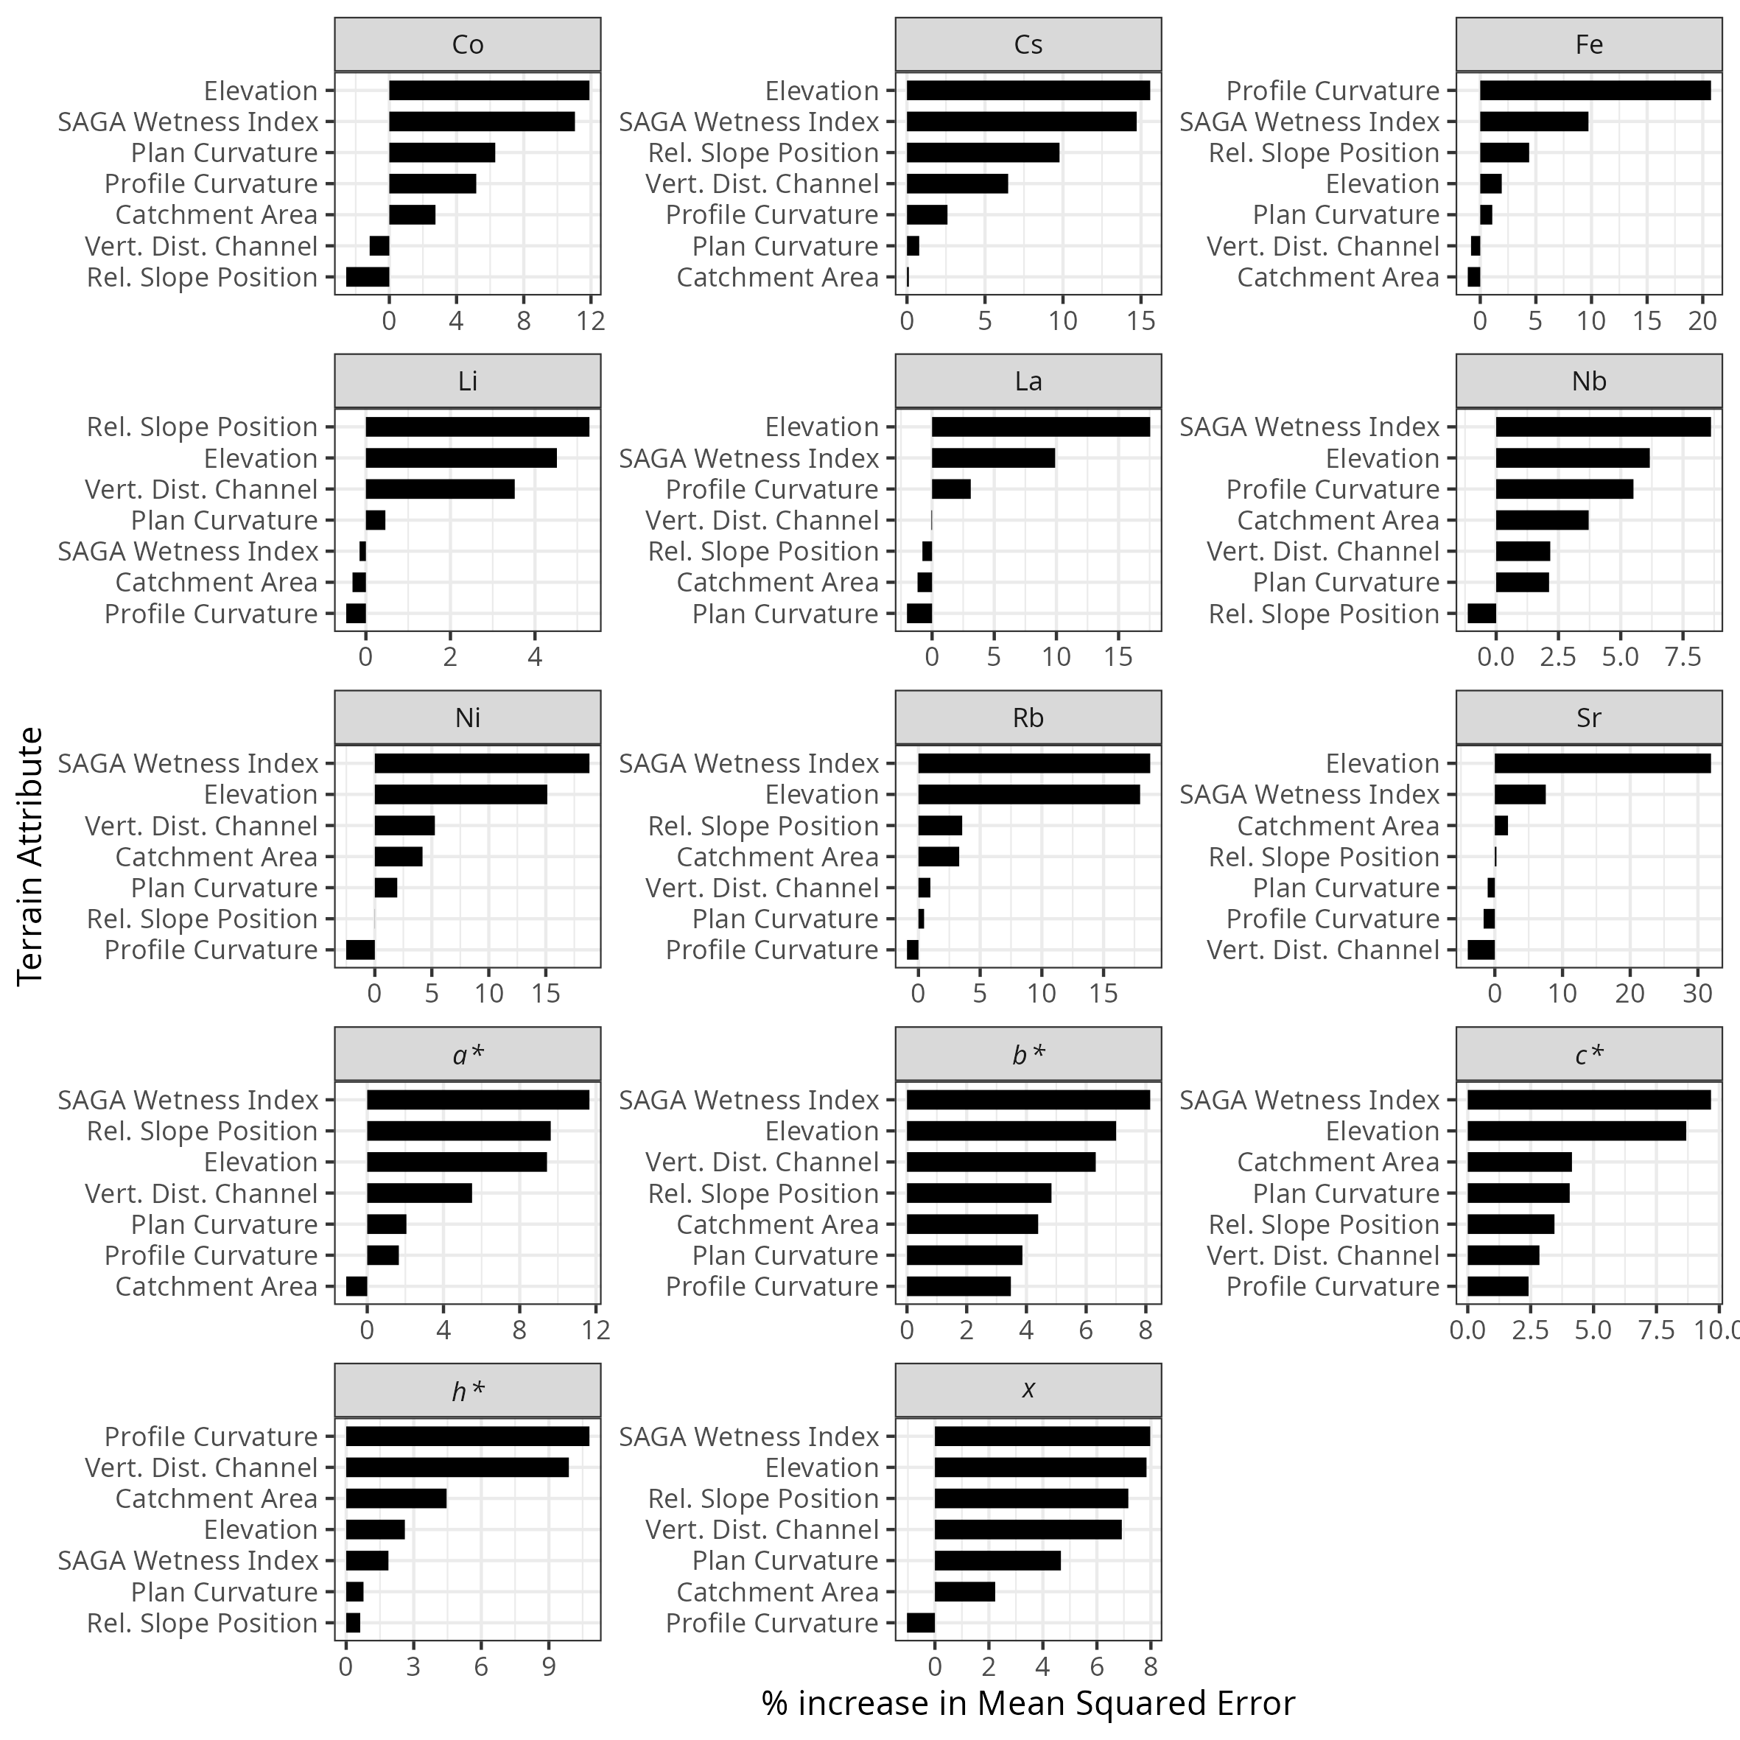Figure S1: Variable importance, expressed as the percentage increase in Mean Squared Error, for soil colour and geochemical fingerprint properties derived from random forest models using terrain attributes as predictorsat the agricultural site.

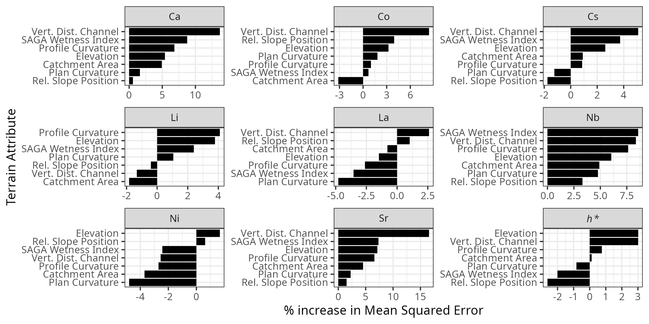Figure S2: Variable importance, expressed as the percentage increase in Mean Squared Error, for soil colour and geochemical fingerprint properties derived from random forest models using terrain attributes as predictorsat the forest site.

